Vegan Cooking Class Recipes Session 69 (December, 2019)

- Cranberry Bread (page 1)
- Vegan Pizza Dip (page2)
- Quick Pizza Sauce (page 2)
- Artichoke/Spinach Dip (page 3)
- Cherry Pistachio Biscotti (page 4)
- Chocolate Molasses Cookies (page 5)

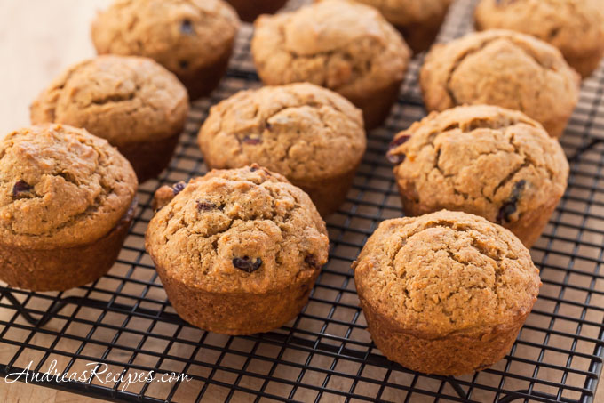

Quick No-Fat Cranberry Bread

2 c. whole wheat pastry flour
3/4 cup Sucanat or other natural sugar
1 tsp. baking powder
1 tsp. baking soda
1 cup orange juice
1 egg replacer (1 Tbsp. ground flaxseed meal with 3 Tbsp. water)
1½ c. fresh (or frozen) cranberries, finely chopped in food processor)
½ c. walnuts, chopped

- Preheat oven to 350° F.
- Mix together flour, sugar, baking powder, and baking soda in a large bowl.
- Stir in orange juice and egg replacer. Mix just until blended.
- Fold in cranberries and walnuts. Spread evenly in a nonstick bread pan.
- Bake for approximately 45 minutes or until toothpick inserted in center comes out clean.
- Cool on rack for 15 minutes before removing.

Tips: You can also use this recipe to make muffins and serve them for breakfast. (I baked Mini-Muffins for 25 minutes and large muffins for 35 minutes). This recipe is great for holidays.
Author: Leanne Campbell, PHD
Vegan Pizza Dip

Ingredients
12 oz. jar pizza sauce (or see quick sauce recipe below)
1 tomato thinly sliced
2 Tbsp. chopped fresh basil

Mushroom-onion mix
½ medium onion, chopped
8 oz. sliced white or cremini mushrooms or combination
¼ tsp. dried thyme
½ to 1 tsp. oregano
¼ tsp. salt (or more to your preference)
¼ tsp. pepper flakes

Mozzarella Cream Sauce
1/3 heaping c. raw cashews, soaked 5 minutes in warm water
1½ Tbsp. tapioca starch
1 Tbsp. potato starch or use more tapioca
1 clove garlic
1 tsp. lemon juice
½ tsp. white miso (or omit, but recommended)
1/2-3/4 tsp salt
1 Tbsp. nutritional yeast

- Place onion in a skillet over medium heat and cook for 5 minutes, adding a bit of water to keep from sticking.
- Add mushrooms and toss well. Cook for 3-4 minutes till golden.
- Drain cashews. Blend cashews with all the mozzarella cream ingredients till smooth.
- Preheat oven to 400° F degrees.
- In a loaf pan or other small baking dish, add half of the pizza sauce and spread it out.
- Add half of the mozzarella cream over top (it will be thin).
- Distribute the mushroom mixture over the cream. Repeat layers.
- Sprinkle olives over top. Place tomato slices on top. Sprinkle with thyme and oregano and salt.
- Bake at 400° F degrees for 25 minutes.
- Sprinkle fresh basil and pepper flakes over top and serve with crusty bread, pita bread, pita chips, etc.

Quick Pizza Sauce
6 oz. tomato paste
2 tsp. (or more) Italian herbs
¼ tsp. salt
2 tsp. minced garlic
Water to thin: ¾ to 1 c.

Mix everything and use for pizza sauce.
Author: Vegan Richa

Vegan Artichoke/Spinach Dip

1 c. nondairy milk (no vanilla, unsweetened)
½ c. raw, soaked cashews
1 tsp. lemon juice
1 tsp. apple cider vinegar
3 Tbsp. nutritional yeast flakes
1 Tbsp. miso
1 Tbsp. onion powder
1 Tbsp. garlic powder
½ tsp. salt
¼ tsp. liquid smoke (optional)

3 T. tapioca starch

1 (14 oz.) can artichoke hearts, drained and roughly chopped
8 oz. frozen chopped spinach, thawed and drained

- Blend the first 10 ingredients until smooth.
- Then add the tapioca starch and blend again briefly
- Put the mixture into a pan and cook on medium, stirring constantly until it all comes together and is stretchy. Lower the heat and stir an additional minute.
- Add the artichoke hearts and chopped spinach and mix well.
- Put into an oven-safe dish and bake with a cover at 350° F. for about 20 minutes. Can then be broiled without the lid for 1 minute for a golden top if desired.
Adapted from the Jaroudi Family on YouTube

Cherry Pistachio Biscotti
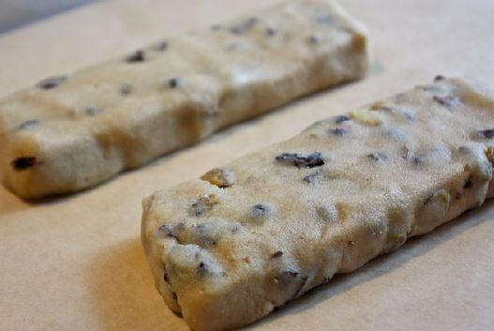
Vegan, Oil-free, Grain-free (a favorite of ours, and others)

Ingredients:
2½ cups tightly-packed blanched almond flour (not almond meal) Best price: Costco about $14 for a 3 pound bag
1 Tbsp. tapioca flour
1 Tbsp. potato starch
2 tsp. ground chia seeds (I mill a bunch and store)
½ tsp. baking soda
½ c. pure maple syrup (Best price: Costco)
½ tsp. pure almond extract
½ c. raw pistachio nuts (Best price: Costco for a larger bag of shelled pistachios)
½ c. unsweetened, no oil dark, dried red cherries (Most dried fruit has added sugar and oil. Trader Joe’s has some with no oil! They are larger so I cut in half or put in food chopper. About $5.99; quite expensive.)
Given the high cost of pistachios, almond flour, and no-oil dried cherries, you may use raisins or dates and almonds or walnuts to reduce cost.

Directions:
- Preheat oven to 350° F.
- Line a cookie sheet with parchment paper.
- Place the flours, chia and baking soda into a food processor and pulse to combine.
- With the machine running, drizzle in the maple syrup and almond extract until the mixture comes together in a ball.
- Transfer to a bowl and mush in the nuts and fruit. Use your hands, it’s easier that way.
- Divide the dough into 4 equal portions and shape into flattened logs about 6″ long and 2½” wide. (It’s okay if the sizes are not perfectly equal.) See photo next page.
- Bake for 15 minutes. Remove and let cool completely (at least one hour; sometimes I don’t wait that long, sometimes I wait many hours. Seem to turn out fine either way).
- Using a VERY sharp, non-serrated knife, slice the logs on a diagonal into ¾” strips.
- Place them back on the parchment-lined cookie sheet, cut side down, and bake for 30 minutes more at 300° F, flipping them once halfway through baking. I often bake for only 12-13 minutes each side and check to make sure they are not getting too brown.
- Let cool and serve. They freeze well.
The best part about biscotti is their versatility. You can create and create, to your heart’s desire. Make them chocolate with almonds, chocolate chip, and put whatever dried fruits, nuts and flavors you like in them. These also make perfect holiday gifts! They travel well and last a long time out of the fridge.
https://helynskitchen.com/2013/12/cherry-pistachio-biscotti-vegan-grain-free-and-oil-free.html

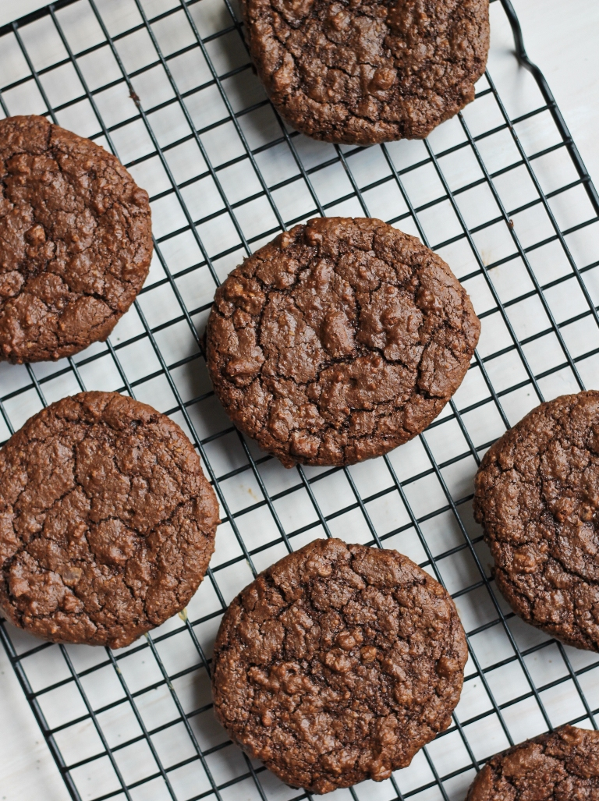
Dark Chocolate Molasses Cookies
(Vegan and Gluten-free)
These Vegan Gluten-free Grain-free Dark Chocolate Molasses Cookies are wonderfully chewy with a rich chocolate flavor that is beautifully enhanced by rich molasses. These are strong in flavor and not for the faint of heart. Only serious chocolate lovers here!

Instructions
1 c. blanched almond flour (for a nut-free option, see note below)
¼ c. tapioca starch/flour
¼ c. unsweetened cocoa powder
1 tsp. baking powder
¼ tsp. fine salt
1 Tbsp. ground flaxseed
½ c. pure maple syrup
1 Tbsp. + 1 tsp. creamy peanut butter or almond butter
1 Tbsp. blackstrap molasses
1 tsp. vanilla extract
½ c. dairy-free dark chocolate chips (use semi-sweet if you don't like a dark flavor)

To make this recipe nut-free, you can use raw, unsalted sunflower kernels and grind them up in a food processor into fine flour and use that in place of almond flour. For this option, increase the flour amount to 1¼ cups sunflower "flour," as it tends to be lighter in baking. Use sunbutter in place of the nut butter.

- Pre-heat an oven to 375 degrees and line a dark metal sheet pan with parchment paper. I have found that dark metal pans bake cookies much crispier on their bottoms, versus aluminum pans, where the bottoms don't seem to bake as well.
- In a small bowl, add the syrup and whisk in the flaxseed well and set aside for 5 minutes to thicken.
- Meanwhile, in a large bowl, whisk together the almond flour (or sunflower), tapioca, baking powder, cocoa and salt together and whisk well. Stir in the chocolate chips.
- Next, stir in the molasses, peanut butter and vanilla into the reserved flaxseed mixture and mix well. Pour over the flour mixture and stir for a couple of minutes until it all comes together and thickens up. It should be sticky and fairly thick. If it is on the runny side, add a touch more almond flour.
- Drop by large spoonfuls onto the prepared sheet pan and slightly smooth/spread out the batter with the back of the spoon to about 2 inches wide, about 1/4 inch thick. This will ensure even baking. Make sure to space each cookie 1-2 inches apart from each other, as they will spread a lot when baking. They will be large and beautiful! Bake for 8-10 minutes or until cracked on top and slightly firm. I took mine out at around 9 minutes. They will crisp up while cooling. If you prefer them a bit crispier, bake for another minute or two. Cool 10 minutes on the pan before transferring them to a cooling rack.
- To make them as sandwiches, simply spread chilled peanut butter or almond butter (sunbutter for nut-free) in between 2 cookies. Keep them stored in the fridge to hold the sandwich shape best!
Author Brandi Doming at https://thevegan8.com/dark-chocolate-molasses-cookies-gluten-free

