Vegan Cooking Class Recipes Session 68 (November, 2019)

- Vegan Pumpkin Cake (page 1)
- Coleslaw (page2)
- Tofu Cashew Mayonnaise (page 2)
- Black Bean Burgers (page 3)
- Jackfruit Sloppy Joe Filling (page 3)
- Vegan Deli Meat (page 4)

Vegan Pumpkin Cake with Chocolate Pumpkin Ganache
¾ c. pumpkin puree (not pumpkin mix)
⅓ c. maple syrup
¼ c. plant milk
2 Tbsp. applesauce (or more milk)
½ tsp. vanilla extract
1 tsp. apple cider vinegar
2 tsp. pumpkin pie spice (add ½ tsp. cinnamon for added spice if desired)
1-3 Tbsp. natural sugar, for sweeter
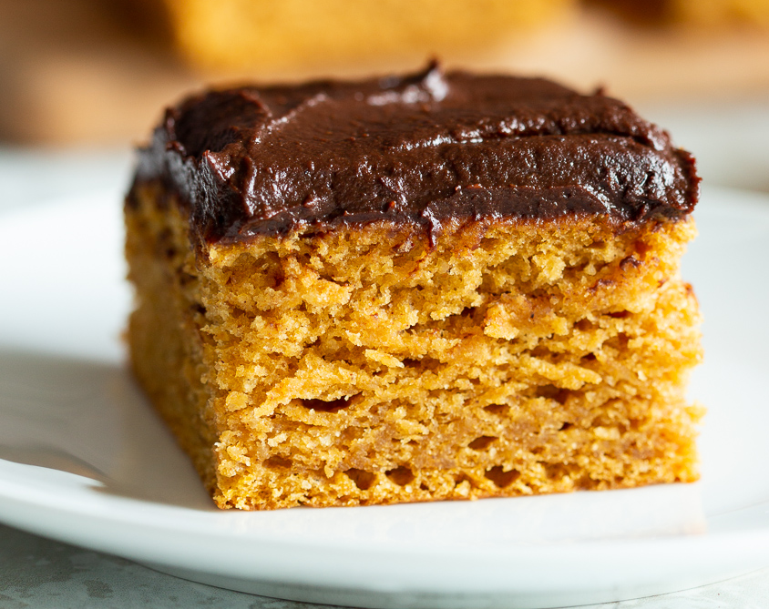
1¼ c. flour
3 Tbsp. almond flour (or more flour)
2 tsp. baking powder
¼ tsp. salt

Ganache:
½ c. pumpkin puree
½ c. vegan chocolate chips
2 Tbsp. plant milk
1-2 Tbsp. natural sugar, optional

- Line 8 or 9 inch cake pan with parchment paper. Preheat oven to 350 degrees.
- Mix all the wet ingredients in a bowl until well combined.
- Add the dry ingredients and mix until just about combined. The batter will be thick. Spread evenly in the prepared pan.
- Bake for 30 minutes (25 minutes for smaller pan). For muffins or cupcakes, bake for 20-22 minutes.
- Cool for 5 minutes, then remove from the pan and cool completely before frosting. At this point you can brush the cake with a mix of 1 Tbsp. maple syrup and 2 tsp. water to keep cake soft and moist.
- Make the ganache: Heat pumpkin puree and milk over medium heat until bubbling. Add chocolate, whisk for a few seconds, then take off the heat. Continue to whisk until all the chocolate is melted and the mixture is smooth.
- Cool for 5 minutes and then chill for 15 minutes to thicken. Spread over the cake. Optional: top with chopped hazelnuts, coconut or candied pecans. Serve. The frosted cake can be refrigerated for up to 4 days or frozen for up to a month.
Adapted from recipe by Vegan Richa

Coleslaw
6 c. shredded green cabbage
1 carrot, shredded
½ c. sliced green onion
1 red or orange bell pepper, seeded and diced medium
½ c. Tofu Cashew Mayonnaise
¼ tsp. smoked paprika
1 tsp. celery seed
1 tsp. onion powder
¾ tsp. sea salt
2 Tbsp. apple cider vinegar
2 Tbsp. agave nectar

- In a large bowl, combine the cabbage, carrot, green onion, and bell pepper.
- Add the mayonnaise, seasonings, vinegar, and agave and toss thoroughly to coat the vegetables with the sauce mixture until well combined.
- Chill in the refrigerator before serving.
Adapted from Kim Campbell in The PlantPure Nation

Tofu Cashew Mayonnaise
(Vegan, no refined oil) makes about 2 cups

A mayonnaise that is actually good for you, and great tasting too! It adds some protein and healthy whole-food fats as well as vitamins and minerals to whatever you eat it with.

⅓ c. raw cashew pieces, soaked at least 3 to 4 hours (or ⅔ c. soaked cashews – soaking ahead & freezing is a great idea if you make it often like we do!)
1 box Mori-Nu tofu (firm or extra-firm)
1 tsp. salt
1 tsp. tahini (optional)
1 tsp. apple cider vinegar
1 tsp. maple syrup (optional)
2 Tbsp. lemon juice
2 Tbsp. water
¼ tsp. mustard powder

¼ tsp. xanthan gum (optional, but this thickens it more and gives it a slicker “mouthfeel”)

- Measure the first 9 ingredients into a blender and blend until very smooth. If not using a high powered blender, you may need to divide the recipe into 2 batches.
- Add the xanthan gum and blend again briefly until well mixed. Store in the refrigerator. Should keep for about a week or even a little longer.
This can be used as a base for many different sauces and dressings. Experiment!
Adapted from Kim Campbell in The PlantPure Nation
Black Bean Burgers
In a food processor mix the following until the nuts and oats are well chopped only (2 or 3 pulses)
1 c. rolled oats
½ c. walnut pieces
¼ tsp. turmeric powder
1 Tbsp. ground flax seed
1 tsp. onion powder
½ tsp. garlic powder
½ tsp. smoked paprika

Next add the following and run the processor until evenly mixed. It will be a soft dough.
½ c. chopped red onion
1½ c. cooked black beans (or 1 can 15 oz.), drained
½ of 4 oz. can mushroom pieces and stems (about ¼ c.), drained and roughly chopped
2 Tbsp. almond butter (or tahini)
1 Tbsp. fresh parsley, chopped fine (or dry)
1 Tbsp. white miso paste
1 Tbsp. Liquid Aminos
½ tsp. liquid smoke

- If time permits refrigerate the dough until cool. It will be firmer and easier to handle. Preheat oven to 375 F.
- Measure scant ½ c. portions (for 5 burgers) onto baking pan lined with parchment paper or a silicon mat.
- Form into round flat burgers, about 1/3 inch thick or so. Mine were about 4 inches across.
- Bake for 20 minutes. Then flip them over carefully and bake for another 15 minutes.
By Diana Adams

Jackfruit Sloppy Joe Filling
1⅓ c. tomato sauce
4 pitted dates
1½ tsp. chili powder
½ tsp. garlic powder
¼ tsp. smoked paprika
¼ tsp. liquid smoke
Salt to taste

Blend above ingredients together until all is smooth with no chunks of dates. If you don’t have a high power blender, you can soak the dates first until soft in a little water or in the tomato sauce.

Place the above mixture in a pan and add:
1 c. cooked Farro
1 14 oz. can green Jackfruit, drained and chopped

Heat the mixture together and serve on top of a hamburger bun. Can also be refrigerated or frozen for later use.
Adapted from Forks Over Knives magazine, Summer 2019

Homemade Vegan Deli Meat

12 oz. extra firm tofu, drained
2 c. vegan chicken broth (I used vegetable broth with some poultry seasoning)
3 Tbsp. tomato paste
2 Tbsp. nutritional yeast
1 Tbsp. tamari
2 tsp. liquid smoke
2 tsp. poultry seasoning
2 tsp. onion powder
2 tsp. garlic powder
1-2 tsp. salt
1 tsp. smoked paprika
¼ tsp turmeric
1 tsp. powdered sage
1 tsp. thyme

3 c. vital wheat gluten
¼ c. chickpea flour

- Set up a large steamer pot on your stove and bring water to a boil then lower to simmer.
- In a high-speed blender, add all the ingredients from the tofu to the thyme and blend until smooth. Set aside.
- In a large bowl, add the wheat gluten along with the chickpea flour and mix until uniform. Pour in the blended mixture and with a spatula or wooden spoon, mix everything until a dough forms.
- Flour a clean surface with chickpea flour and knead the dough for 3-4 minutes, or until it becomes soft and smooth. It will seem sticky at first, but it's supposed to be that way (you may add a couple tablespoons of flour if too wet, but a dry dough will not produce an ideal result).
- Lay a 12 inch piece of aluminum foil on the counter and then place a 10 inch piece of parchment paper on top. Place the dough at the bottom of the parchment paper and press it into a tall and thick log with your hands. First, wrap the parchment paper around the dough, leaving the ends open. Next, place the wrapped log towards the bottom of the foil and then wrap the foil around the log. Twist the ends up like a candy wrapper to seal the dough in. Don't make it too tight-the dough will expand. (I cut the log into 2 and wrapped the halves separately to fit into my steamer).
- Place the log into the steamer basket and steam for 1 hour.
- Preheat the oven to 350 degrees. Remove the log from the steamer and place it on a baking sheet. Place it into the oven and cook for 30 minutes.
- Remove the log from oven, carefully unwrap it and allow it to cool completely before slicing.
- The log can be placed into an airtight container in the frig and stored for up to 2 weeks. When you are ready to eat the deli meat, use a sharp knife to slice it. The log can be frozen (unwrapped) in an airtight container. Allow it to thaw completely before slicing.
Adapted from a recipe by Jasmine@Sweet Simple Vegan

