Vegan Cooking Class Recipes Session 62 (December, 2018)
Holiday Foods

- Arugula Salad (page 1)
- Ricotta Cheese (page1)
- Spinach Lasagna (page 2)
- Connie’s Cream Cheese (page 3)
- Smoky Cheese Ball (page 3)
- Gingerbread Spice Cake (page 4)
- Gingerbread Spice Mix (page 5)
- Cream Cheese Frosting (page 5)
- Nürnberg Lebkuchen (page 6)

Arugula Salad with Apples, Cranberries & Smoked Almonds
8 c. arugula
1 large apple, peeled, cored, quartered, and thinly sliced
⅓ c. dried cranberries
2 – 3 Tbsp. lemon juice
3 Tbsp. tahini
¼ tsp. agave syrup
¼ tsp. lemon zest
¼ tsp. salt
1 Tbsp. finely minced shallots or onion
½ c. chopped smoked almonds

- In a large bowl, combine arugula, apples, and cranberries.
- In a small mixing bowl, combine lemon juice, tahini, agave, lemon zest, salt and shallots. Whisk well for dressing.
- Sprinkle the almonds over the salad, drizzle with the dressing, and toss to mix.
Adapted from recipe by Julie Hasson

Ricotta Cheese
3 garlic cloves, pressed or minced
1 14-oz. block extra-firm tofu
¼ c. nutritional yeast
¼ tsp. nutmeg
½ tsp. onion power
1 Tbsp. lemon juice
½ tsp. salt

Pulse all ingredients in a food processor or mash in a bowl with a potato masher ’til desired consistency is obtained.
Inspired by Kim Campbell in “The Plant Pure Nation Cookbook”

Spinach Lasagna
4-6 garlic cloves, chopped
1 onion, diced
8 oz. mushrooms, sliced
¼ c. vegetable stock, for sautéing
10 oz. fresh spinach
1 tsp. Italian Seasoning
6¼ c. Marinara Sauce, (your favorite sauce; I used of Whole Foods brand: “365” Organic Marinara Pasta Sauce, Fat Free)
12 Lasagna noodles, uncooked (I used “Tinkyada Pasta Joy” Organic Brown Rice Pasta Lasagna, available at Placerville Health Food Co-Op, but any kind should work
2-8 oz. tubs Ricotta Cheese (I used “Kite Hill” brand, available at Placerville Health Food Co-Op)
Optional: 8 oz. Mozzarella shreds (I used “So Delicious” brand; you can use any other plant-based brand too, or leave it out)

- Preheat oven to 375° F.
- In a small skillet over medium-high heat, sauté the onions and mushrooms until tender, adding vegetable stock if it starts sticking.
- Add garlic and cook for a couple of minutes. Stir in Italian Seasoning. Set aside.
- In a 9x13 inch casserole dish, assemble your lasagna in this order (noodles are not cooked):
½ c. marinara sauce
4 noodles
Half of the ricotta cheese
Half of the mushroom mixture
Half of the spinach leaves
⅓ of the mozzarella shreds
1¾ c. marinara sauce

4 noodles
Remaining ricotta cheese
Remaining mushroom mixture
Remaining spinach
⅓ of the mozzarella shreds
1¾ c. marinara sauce

4 noodles
Remaining marinara sauce
Remaining mozzarella shreds

4. Cover with foil and bake for 60 minutes. (80 minutes for whole-wheat pasta)
5. Let stand 30 minutes before serving. Great the next day and freezes well too.
By Edith Tsacle

Connie’s Vegan Cream Cheese
(She calls it “Fresh Vegan Ricotta-Cheese”) adapted from Connie’s RAWsome Kitchen. Watch the video if you wish at https://youtu.be/Ng3uHyde1Us. All her recipes are super tasty!

- Soak 1¼ cups of raw almonds overnight. They should expand to 2 cups. Rinse well.
- Blanch in boiling water and pop out of skins if you want a whiter cheese (optional). Rinse again.
- Blend in high-power blender 2 cups soaked almonds with enough vegan milk (any kind that is pure with no additives) to cover. When smooth, stop the motor and add water to 7 cup mark. Blend again briefly to mix well.
- Strain through a cloth or nut milk bag to make almond milk.
- Next, heat all the milk plus 1 Tbsp. of sea salt* in a large pan to a low simmer. It can boil over if it gets too hot, so watch it! Let simmer slowly until it reduces to a nice thick creamy consistency. Stir it occasionally with a heat-proof silicon spatula so that it doesn’t stick on the bottom.
- Take the pan off the heat and add ¼ cup lemon juice plus around another 1 Tbsp. Move it very gently with a spoon to only distribute the juice, then leave it alone to clabber (3 or 4 hours). Put in the fridge after the first hour.
- Next, place the cold, clabbered milk gently in a cloth or nut bag again to strain out the whey. Let sit for an hour or so, until most of the whey has drained. You can now fold the cloth over the top and place something on top of the cheese curds to help it drain more. A little later you can change it to a smaller strainer/pan setup with a clean dry cloth so it doesn’t take so much room and place it in the fridge several hours or overnight.
- Scrape out the cheese when it has reached the desired firmness. For frosting, you will want it on the soft side.
- This cheese can be frozen ahead, although the texture will become a little more grainy. But it still tastes good. Just be sure to allow time to thaw before using.
*Note: If you plan to use this for something sweet, you can omit the salt or only use a tiny bit (⅛ tsp.) so it won’t taste flat.

Smoky Vegan Cheese Ball
1 mounded cup (around 9 oz.) vegan cream cheese (or one cheese made from above recipe)
¼ tsp. liquid smoke
½ tsp. vegan Worcestershire sauce (available online or at health food stores)
¼ tsp. onion powder
¼ tsp. garlic powder
Chopped pecans and parsley to roll in, or your choice topping

- Cream the first 5 ingredients together well.
- Chill until firm enough to roll.
- Form a ball.
- Roll in topping to cover
- Wrap in plastic wrap and chill until serving time.
Adapted from recipe at http://mrsmaryannshouse.blogspot.com/2010/12/smoky-cheese-ball.html

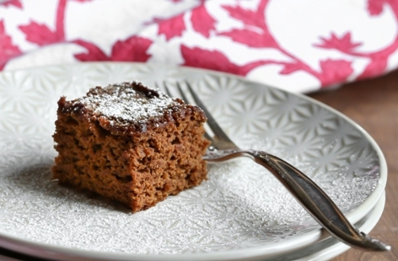

Vegan Gingerbread Spice Cake
1½ c. (192g) spelt flour
¼ c. (40) brown rice flour
2 Tbsp. (16g) cornstarch
2 tsp. (12g) baking soda
4 tsp. gingerbread spice (I used my blend) Diana’s note: I used only 2 tsp. of her blend and 2 tsp. Ceylon cinnamon. Her blend is very spicy!
½ tsp. (3g) fine sea salt
¾ c. (240g) pure maple syrup, room temperature
1 c. (240g) unsweetened applesauce, room temperature
¼ c. (80g) unsulphured molasses (do not use blackstrap or substitutes!)
2 Tbsp. (30g) HOT water

NOTE: You will need a whisk for this cake to ensure a perfectly smooth batter. A spoon will not incorporate the batter well and will affect the texture. Please know that this cake I tested around 10 times to get it just right, so I cannot stress enough the importance of following the recipe and weighing your ingredients for accuracy. I cannot vouch for results if you substitute flours or liquids. The molasses and applesauce are magical for flavor and moisture here and cannot be substituted or the cake will not be moist.
- Preheat the oven to 350°F and line an 8x8 inch square pan with parchment paper going in each direction, cut to fit and with overhang (not bunched in the corners).
- To a large bowl, add the spelt, rice flour, cornstarch, baking soda, spices and salt and whisk very well.
- Make sure none of your liquids are cold before proceeding; otherwise your batter will not be smooth or mix well. In a separate bowl, add the syrup, applesauce, molasses and hot water. Stir until everything is combined and smooth. Now add the liquid ingredients to the bowl of dry ingredients. Whisk gently until all is thoroughly mixed, making sure to get the flour at the bottom, but DO NOT over-mix. As soon as it's smooth, stop mixing. Over-mixing the batter can make the cake dense and the center SINK. Now, taste that batter and tell me it's not out of this world!
- Pour the batter into the prepared pan and smooth out the top evenly to the corners. Bake on the middle rack for 25 to 35 minutes, or when a toothpick or knife comes out clean.
- Cool the cake completely in the pan for a minimum of 1 hour, no exception. This allows the cake to completely cook through. There is a lot of applesauce and moisture in this cake, so you don't want to cut too soon or it will be soggy. After one hour, carefully flip the cake out onto a plate and gently remove the parchment paper. Slice carefully into 16 squares.
- Serve topped with powdered sugar, whipped vegan cream or vegan cream cheese frosting!

Adapted from Brandi Doming at https://thevegan8.com/2017/12/15/vegan-gingerbread-cake

Homemade Gingerbread Spice Mix
Use for pancakes, waffles, cakes, breads, cookies or anything you want to give a gingerbread flavor to. Made with just 5 easy spices!

2 Tbsp. (16) Ceylon cinnamon
3 Tbsp. (24g) ground ginger
1 Tbsp. (8g) ground nutmeg
1 Tbsp. (8g) ground allspice
1 Tbsp. (7g) ground cloves (Do not omit no matter what! This is a crucial ingredient to the classic gingerbread flavor.)

Add everything to a bowl and whisk very well. Add to a sealed jar and give another shake. Store for up to 6 months. I like to give the jar a really good shake before each use.
Use this blend to replace any recipe calling for gingerbread spice for the amount listed for in the recipe. Or, add to pancakes, waffles, muffins, anything you like to give it a gingerbread flavor! Depending on the recipe, start with 1-2 teaspoons and taste and adjust the batter after tasting.
Adapted from Brandi Doming at https://thevegan8.com/2017/12/11/homemade-gingerbread-spice-mix

Vegan Cream Cheese Frosting
1 c. soft vegan cream cheese (you will need a cream cheese that isn’t very salty for this recipe)
2 Tbsp. raw powdered sugar (just blend some regular raw sugar in a dry blender until powdery and sift before using)
8 drops of Vanilla Crème Liquid Stevia (SweetLeaf brand, available on Amazon). If you don’t have this you could substitute more sugar and some vanilla to taste.

Mix well with a fork or spoon until creamy and frost your cake just before serving.
By Diana Adams

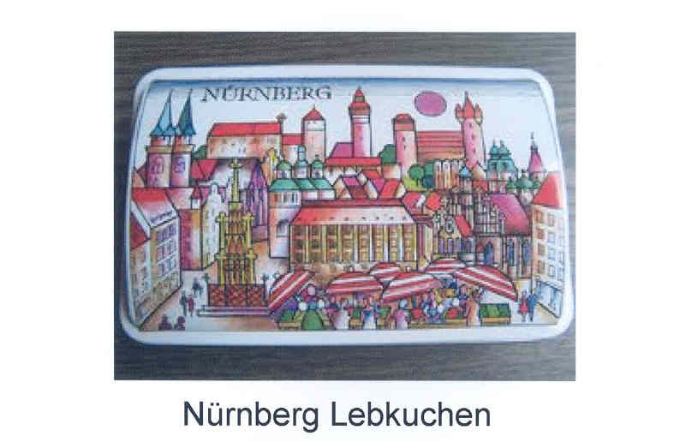

Lebkuchen was invented by German monks in the 13th century and German Lebkuchen bakers were recorded as early as 1395 in the city of Nurnberg. I learned to make Lebkuchen from a Master baker in Nurnberg when I lived there in the mid 1980s. The recipe I follow is from an original family recipe dating back to the mid 1400s.
Dry Ingredients Wet Ingredients
Almond Flour ` 4 cups Liquid from 2 15oz cans of Garbanzo Beans
White Flour 1 cup Sugar 1.5 cups
Diced Marzipan 1 cup Cream of Tartar Powder ½ tsp
Diced Candied Fresh Orange Peel 1/2 cup Vanilla Extract 2 tsp
Diced Candied Fresh Lemon Peel 1/3 cup Ammonium Bicarbonate 1 Tbs
Diced Dried Apricots 2/3 cup
In a mixer, whip garbanzo bean liquid, sugar, cream of tartar powder, & vanilla until stiff peaks form to make aquafaba.
Dissolve Ammonium Bicarbonate in a little cold water
Mix wet and dry ingredients into a batter, cover and let stand for 5-6 hours
With a wet knife, place batter (mound shape) onto Oblaten wafers
Place in parchment paper covered baking pan and bake at 350 degrees for 20 – 22 minutes
When cool, top with tempered dark chocolate
Cinnamon 11 tsp
Ground Anise Seed 2 tsp
Ground Fennel Seed 2 tsp
Allspice ½ tsp
Cloves ½ tsp
Cardamom 1 tsp
Corriander 1 tsp
Ginger 1½ tsp
Oblaten wafers (50mm) 48 wafers Al Tsacle – December 2018

