Vegan Cooking Class Recipes Session 57 (May, 2018)
Mexican Food
- Fiesta Quinoa Salad (page 1)
- Best Vegan Nacho Cheese Sauce (page 2)
- Really Cheesy Fat-Free Vegan Cheese Dip (page2)
- Homemade Corn Tortillas (page 3)
- Vegan Chorizo (page 4)
- Darla’s Salsa (page 4)
- Green Tomatillo Sauce (page 5)
- Extra Creamy Vegan Guacamole (page 5)

- Almond Milk Sour Cream (page 6)

Fiesta Quinoa Salad (Makes 5-7 Servings)

For the Salad:
1 c. white quinoa, washed and drained
¼ c. red quinoa, washed and drained (see tip)
1 c. corn (fresh or frozen)
2 c. water
A pinch of sea salt
1½ c. cooked or 1 15-oz. can black beans rinsed and drained
¼ c. yellow pepper, finely diced
¼ c. tomatoes, diced
¼ c. cilantro leaves

For the Dressing:
2 Tbsp. lime zest
2 Tbsp. lime juice
2 tsp. ground cumin
2 tsp. chili powder
3 Tbsp. tamari
1 Tbsp. maple syrup
2 tsp. apple cider vinegar

- Place quinoa, corn, and water in a medium saucepan with pinch of salt and bring to a boil. Simmer in covered pan for 20 minutes over low heat.
- Meanwhile, whisk the dressing ingredients in a small bowl until well combined.
- Fluff quinoa with a fork, place in medium bowl, and stir in the black beans, veggies, cilantro and dressing. Season with more salt, if desired.
- Serve immediately, or serve warm or cold the next day.

Tip: If you can’t find red quinoa, you can use all white.

Source: “The China Study All-Star Collection - Whole food, Plant-Based Recipes from your Favorite Vegan Chefs,” by Leanne Campbell, PhD

Best Vegan Nacho Cheese Sauce
Serves: 6+

2 medium potatoes cut in small cubes
2 large carrots, sliced
5 Tbsp. nutritional yeast flakes
3 Tbsp. extra virgin olive oil
5 Tbsp. tapioca starch/flour
Some water (the water from boiled veggies)
1 Tbsp. lemon juice
1 tsp. sweet paprika
2 tsp. salt

- Boil veggies until tender - 20 minutes. Remove from heat and leave them in the water for 10 more minutes.
- Drain them, save some water, about 1½ cup, maybe a little bit more.
- Put all ingredients in the food processor. Blend until smooth.
- Add water, little by little, until you reach the desired consistency. It has to be smooth and semi-liquid.
- Pour the mixture in a large pan over medium heat.
- Stir continuously. You'll see that this sauce will thicken and get sticky. Stir for about 10 minutes.
Serve!
Author: Ruxandra Micu
Source: https://gourmandelle.com/best-vegan-nacho-cheese-sauce

Really Cheesy Fat-Free Vegan Cheese Dip
Makes about 2½ cups
½ c. rolled oats
¼ c. nutritional yeast
2 Tbsp. cornstarch
2 Tbsp. lemon juice
1½ tsp. salt
¼ c. roasted red bell pepper
¼ c. yellow onion
2 c. water

- Place all ingredients in a blender and process several minutes until very smooth and well blended.
- Pour into a saucepan, cook and stir until thickened.
By Jill McKeever

Homemade Corn Tortillas

2 c. of organic white corn masa (corn flour for tortillas)
1½ c. of water approximately

Mix flour and water to a soft consistency, firm and not sticky, like Play-Doh. Use immediately to keep from losing proper texture.

Form 20 balls of masa by rolling on hard flat surface.
In a tortilla maker, place a ball of masa between two pieces of plastic and press flat.

Place a tortilla on a preheated non-stick skillet.
Turn tortilla after a few seconds, and about 20 seconds later, turn again until parts puff up and it finishes cooking.

Azure Standard Co-op is the best locally available source. Go to www.azurestandard.com and search for:
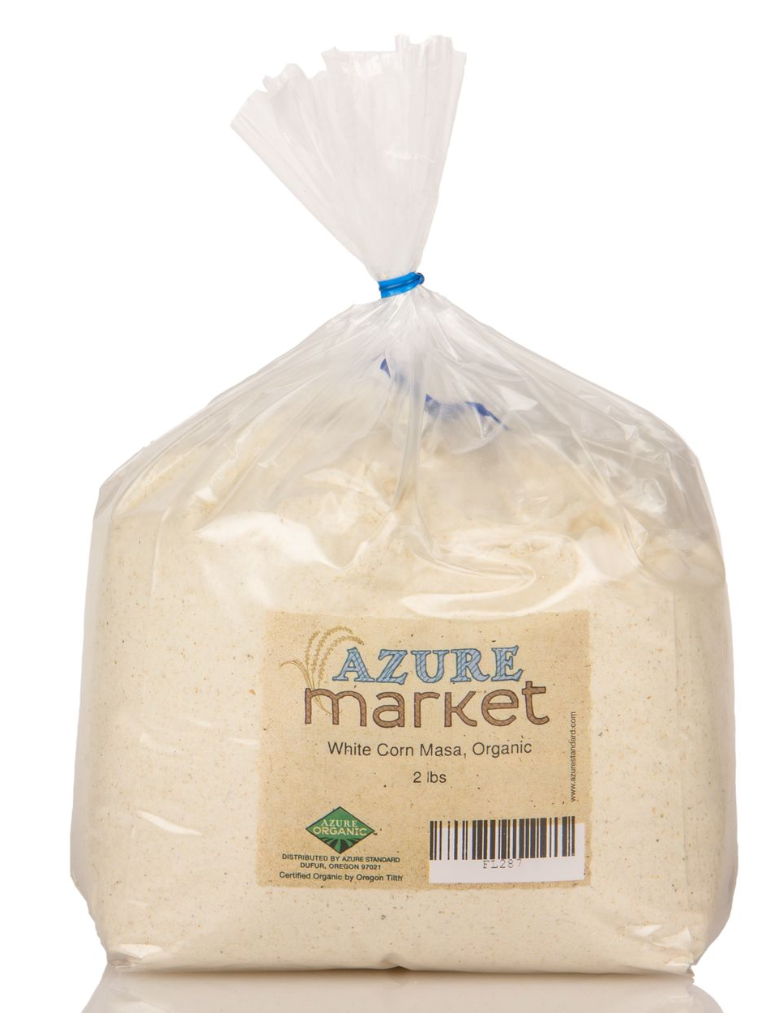
White Corn Masa
Make tamales, tortillas and more. Tastes like REAL Mexican tortillas!

What’s special about Azure Market Masa?

It’s certified organically grown and processed.

- No additives
- Non-GMO

Masa de Maiz is Spanish for corn dough, made from Masa Harina. It is more flavorful and nutritious than corn flour because it has been nixtamalized, or pre-cooked in lime water. This process also allows it to form pliable dough for making tortillas, tamales, etc.

The process of making masa is labor intensive: First, the dried corn is cooked in an alkaline solution. After cooking, the corn is steeped in the cooking liquid. During cooking and soaking, a number of chemical changes take place. The kernels hydrate and absorb calcium or potassium from the cooking liquid. Starches swell and gelatinize. Certain nutrients in the germ are released that allow the cooked corn to be ground more easily, making the dough less likely to tear and break. Cooking changes the corn's protein matrix, which makes proteins and other nutrients like niacin more assimilable. The prepared corn, called nixtamal, is then dried and ground into masa harina (corn flour).

Storage Shelf life is six months, as long as product has been kept cool and dry. Recommended storage temperature is less than 80 degrees.
Available at https://www.azurestandard.com/shop/product/food/flour/corn-masa/white-corn-masa-organic/19098?package=FL287

Vegan Chorizo (Crumbled Sausage)

2 tubs Azumaya tofu, firm (you can also use cooked quinoa instead)

5 dried California peppers (boil until soft, open peppers, remove stem cap and rinse)*
3 dried Pasilla peppers, (same as above)*
*if you don't like spicy, you need to make sure that there are no seeds and no veins after cleaning.
Blend peppers with ½ to 1 cup of the same water you used to boil it.

Then add:
½ onion
Juice of 2 small lemons; ⅛ cup approximately
2 Tbsp. garlic powder
1½ Tbsp. salt
2 Tbsp. soy sauce or Bragg’s
1 tsp. dry oregano, or mix of spices of choice
1 Tbsp. paprika or smoked paprika, or a mix of both

- Blend again.
- Mash the tofu with a fork, pour the salsa into it and mix.
- In a hot skillet, sauté minced onions until lightly browned, and then add the tofu and cook for about 15 minutes to evaporate liquid, stirring as needed to keep from burning.

You can use for tacos, burritos and hotdogs.
By Becky Ramirez

Darla’s Salsa
3 medium tomatoes, quartered
1 medium bell pepper OR 3 mixed small peppers
1 Jalapeño pepper
1 handful cilantro, stemmed
1 red onion slightly chopped
1 clove garlic

- To thicken add tomato sauce.
- Place in salsa maker. Turn on, shake as needed.
- If desired, add hotter peppers to taste.
By Darla DeVargas

Green Tomatillo Sauce
6 tomatillos
3 Serrano chilis
Bring to a boil for about 10 minutes with water (just to cover tomatillos).
Reserve 1 cup of this water.
Then blend:
2 cloves of garlic with the water we reserved, then add:
Cooked tomatillos & chilis
A handful of cilantro
1 small avocado
Salt to taste

Blend again. Ready!
By Oli Rodriguez

Extra Creamy Vegan Guacamole
First make this vegan oil free sour cream adapted from www.glutenfreeveganpantry.com. When I made it, we found it way too sour for our taste. But it makes a super creamy delicious guacamole!

1 c. raw cashews, washed and soaked overnight
3 Tbsp. fresh lemon juice
¾ tsp. sea salt
1 tsp. nutritional yeast
1 c. water

Avocados as desired

- Place all ingredients except avocados into your blender (I used my Vitamix).
- Blend on high for 5-7 minutes, scraping down the sides as needed, until very smooth and creamy. The Vitamix actually cooks this when you run it for several minutes. If using a regular blender, you may want to heat the finished product in a pan on the stove if it is too thin, stirring constantly, until it thickens up.
Now all you do is mash up some avocados and mix some of this creamy goodness into it. You can also season it with a little onion powder, etc. if you wish.
Discovered by chance by Diana Adams; raved about by Fred Adams


Almond Milk Sour Cream

3 c. plain raw almond milk
¼ c. + 1 Tbsp. fresh lemon juice
¼ tsp. sea salt

- In a pan, heat 3 cups of plain raw almond milk. Do not boil, but heat until it is too hot to the touch.
- While that is heating, in a Pyrex (or other heat resistant) bowl, measure out the lemon juice and the salt. Give it a stir and set aside.
- When the milk is hot, gently pour it into the bowl with the lemon juice and salt. Stir very gently and briefly, just to make sure the ingredients all get mixed.
- Place in the refrigerator until cold.
- Then strain through a cloth like as in making the almond milk. ONLY DO NOT SQUEEZE. Just let it sit until about 2 cups of whey drain off. Then scrape the cream out from the cloth into a container and refrigerate. Done!

This is an incredible, original recipe by Nina at https://plantepusherne.dk/almond-milk-sour-cream-vegan. Check out her website for some great pictures of the entire process.

