Vegan Cooking Class Recipes Session 56 (April, 2018)
Rice, Spring Rolls and Nice Cream

- Peanut-Sauce Fried Rice (page 1)
- Peanut Butter Sauce (page 2)
- Fresh Vegan Spring Rolls (page2)
- Mango Sauce (page 3)
- Banana Mango “Nice” Cream (page 3)
- Walnut Maple Cookies (page 3)

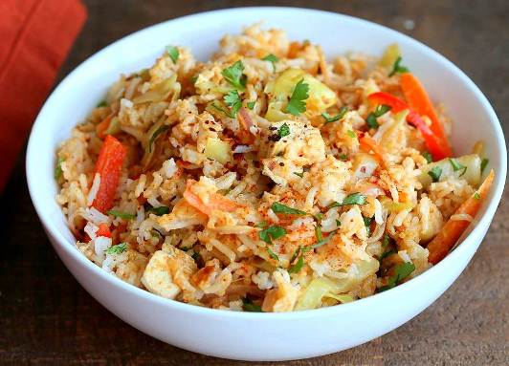

Peanut-Sauce Fried Rice

½ onion, sliced
4 cloves garlic, minced
¾ c. thinly sliced carrots
1 red bell pepper, thinly sliced
7 oz. firm tofu, drained
1 c. chopped cabbage, or broccoli
1½ c. Peanut Butter Sauce (see recipe on next page)
3 c. cooked rice
Salt to taste
Red Pepper Flakes to taste (optional)
1 tsp. fresh lime or lemon juice
¼ c. chopped fresh cilantro

- Sauté onion with salt and a little water if needed for 2 -3 minutes.
- Add the garlic, carrots, and bell pepper. Cook and stir for another 2 minutes.
- Add the tofu and cabbage. Cook and stir for 2-3 minutes more.
- Then add the Peanut Butter Sauce. Mix well. Cover and cook 3 minutes until sauce gets bubbly.
- Last, add the cooked rice and mix well and carefully so it doesn’t spill out of the pan.
- Cover and cook about another 2 minutes.
- Taste and adjust salt. If it is too dry, you can add a little more water or non-dairy milk and mix well. Cover and cook another minute. Then take it off the heat and let it sit another 2-3 minutes.
- Add the lime juice and cilantro and red pepper flakes (if using) just before serving.
Adapted from Vegan Richa’s Everyday Kitchen

Peanut Butter Sauce
Makes about 3 cups
½ c. peanut butter (or almond butter)
2½ inch piece of fresh ginger
3 – 4 cloves garlic
2 Tbsp. Liquid Aminos
1 Tbsp. fresh lime juice
Zest of 1 lime
2 tsp. apple cider vinegar
1 Tbsp. Sriracha sauce (optional) we used ¼ tsp. smoked paprika instead
½ tsp. salt
2½ Tbsp. raw sugar
½ tsp. toasted sesame oil
1 can coconut milk
2 Tbsp. chopped fresh cilantro

Blend garlic and ginger in half the can of coconut milk until smooth. Then add remaining ingredients and blend. Use as a sauce or a dressing for just about anything!
Adapted from Vegan Richa’s Everyday Kitchen

Fresh Vegan Spring Rolls
These spring rolls are a light yet filling dinner idea for those times you don't want to cook but need a quick and easy entrée.
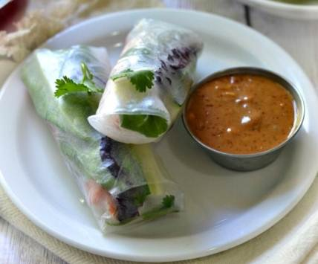
6 rice paper sheets
Rice noodles
Red bell pepper
1 cucumber, cut into matchsticks
½ c. red leaf lettuce (or lettuce of choice)
¼ c. cilantro
Avocado
Mint
Broccoli slaw

- Soak a rice paper sheet very briefly in hot water. Take out and place on a clean flat surface.
- Place the noodles, red bell pepper, cucumber, etc. on the soaked rice paper. Be sure to leave enough margins on the edges. This is very similar to wrapping a burrito.
- Roll from the side closest to you, folding over the left and right side halfway through (there are some good videos online if you need to watch first).
- Repeat until each roll has been made.
- Slice in half if desired and serve with yummy dipping sauces!
Adapted from www.forkandbeans.com
Mango Sauce
1 ripe mango
1 inch knob fresh ginger peeled and roughly chopped
Juice of one large lime or two small limes
Juice of one orange
2 Tbsp. sweet chili sauce (more if desired)
1 clove garlic
Dash of salt
4 or 5 stalks fresh cilantro

Blend all except the cilantro. Add cilantro and pulse until chopped.
Add water, lime, or orange juice to thin if desired.
By Edith Tsacle

Banana/Mango “Nice” Cream
2 ripe frozen bananas
⅔ c. frozen mango pieces
1 Tbsp. lime juice
⅓ c. coconut milk
Zest of lime for garnish

Blend all until smooth in the food processor.
By Edith Tsacle

Walnut Maple Cookies
2½ c. walnuts, ground in food processor
⅔ c. whole wheat pastry flour (for gluten-free, use almond meal and coconut flour)
1 tsp. salt
⅓ c. flaxseed meal
½ tsp. Ceylon cinnamon
⅓ c. carob chips (optional)
½ c. + 2 Tbsp. maple syrup
2 tsp. vanilla

- In a small bowl add all the ingredients in the given order. Mix well.
- Spray a large cookie sheet (or use parchment paper) and preheat oven to 350° F.
- Drop dough on cookie sheet with a spoon and flatten with a fork.
- Bake for 10 to 15 minutes or until golden brown, checking often to prevent burning.
- Let cool before removing from cookie sheet.
Makes about 15 cookies.
Note: The cookies can burn easily and become hard if too dark. Use a double-insulated cookie sheet for baking, and bake on the middle rack of the oven.
Adapted from a CHIP Program recipe handout; shared by Laurie Walsh

