Vegan Cooking Class Recipes Session 55 (March, 2018)
Potato Bar Fixin’s

- “Fried” Cabbage & Soy Curls (page 1)
- Cauliflower Cream Sauce (page 2)
- Almond Milk Sour Cream (page2)
- Raw Almond Milk (page 3)
- Roasted Corn Salsa (page 3)
- Smokey Sprinkles (page 4)
- Applesauce Muffins (page 4)
- Buckwheat Pancake Mix (page 5)

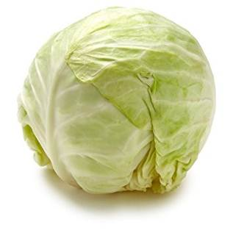

“Fried” Cabbage and Soy Curls (Low fat)
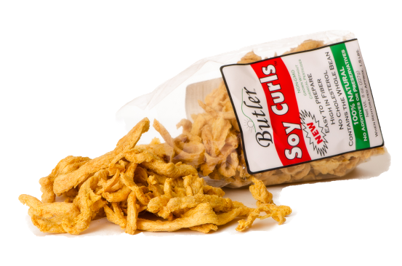
½ small onion sliced thinly
½ small green cabbage sliced thinly
1 handful of dry soy curls
Vegan chicken style broth, enough to cover the Soy Curls

- Soak the Soy Curls in hot chicken style broth.
- Slice the onion and start them cooking in a dry non-stick frypan. Keep an eye on them so that they brown but don’t burn. A spoonful of broth can be added if they start to stick.
- While that is cooking, slice up the cabbage. When the onion has caramelized, add in the sliced cabbage and mix well. Allow to cook with no added oil, turning now and then so it doesn’t burn.
- When it is mostly cooked, add in the soaked Soy Curls (not the broth). Continue to cook and turn occasionally until the liquid has steamed off and the cabbage is the softness you prefer. If you prefer it really soft and a bit caramelized (we do) you may add a bit more broth now and then to deglaze the pan. Salt and season to taste.
By Diana Adams

Soy Curls are made from whole non-GMO soybeans, and can be purchased on Amazon, or obtained directly from www.butlerfoods.com. This web site also lists the nearest stores that carry them.

Cauliflower Cream Sauce

2 c. cauliflower florets
¼ c. cashews
1 tsp. nutritional yeast
1 tsp. lemon juice
½ tsp. apple cider vinegar (optional)
2 tsp. (or more) cooking water
Salt to taste

- Cook cauliflower with cashews in 2 cups of water until cauliflower is soft. Reserve cooking water.
- Put everything in the blender except salt and the cooking water (I didn't need to add any).
- Blend until smooth.
- Add salt to taste and extra lemon juice or vinegar if you like (I added a bit more of each).
Inspired by “The Ultimate Vegan Cookbook for Your Instant Pot” by Kathy Hester

Almond Milk Sour Cream

3 c. plain raw almond milk (see recipe on next page)
¼ c. + 1Tbsp. fresh lemon juice
OR ¼ c. + 1 Tbsp. pure water with 1½ tsp. lactic acid powder (This is the same acid that is formed when making yogurt – without all the work! It makes the milk clabber without the lemon flavor. Available on Amazon. It is DAIRY-FREE.)
¼ t. sea salt

- In a pan, heat 3 cups of plain raw almond milk. Do not boil, but heat until it is too hot to the touch.
- While that is heating, in a Pyrex (or other heat resistant) bowl, measure out the lemon juice (or water and lactic acid powder) and the salt. Give it a stir and set aside.
- When the milk is hot, gently pour it into the bowl with the acid and salt. Stir very gently and briefly, just to make sure the ingredients all get mixed.
- Place in the refrigerator until cold.
- Then strain through a cloth like as in making the almond milk. ONLY DO NOT SQUEEZE. Just let it sit until about 2 cups of whey drain off. Then scrape the cream out from the cloth into a container and refrigerate. Done!

This is an incredible, original recipe by Nina at www.PlantePusherne.dk. I only thought of replacing the lemon juice with lactic acid. Check out her website for some great pictures of the whole process.

Lactic Acid info: http://vegtastic.net/2011/01/is-lactic-acid-vegan
Raw Almond Milk
Soak about 1½ c. of dry raw almonds for at least 8 hours or overnight. If you plan to do make this often, soak a larger amount and keep the extra soaked almonds in the freezer for when you need to make more milk.
Soaked Raw Almonds (2 cups)
Purified Water (6 cups for the milk)
Flour sack dish towel or similar cloth; nothing special as this will become stained now. Be sure it’s clean and with NO fabric softener.
Colander and pot or bowl to catch the milk (big enough for at least 6 cups)

Blend the rinsed, soaked almonds in the 6 cups of water. I like to start with a small amount of the water, about 2 cups, until it is smooth. Then add the rest of the water and just blend briefly to mix. If you don’t have a high powered blender, you can break this down into smaller amounts, according to the strength of your blender.

Place the colander on top of the pot and spread the cloth over the colander.
Then pour the almond liquid into that and let it drain a while (15-20 min. or more). Set your timer and go do something else while you wait. The longer you let it drain, the less you will have to squeeze out by hand.

Finally, squeeze the pulp to get the remaining milk out. This is the creamy part, so don’t get lazy! Make sure your hands are clean and twist the edges of the towel closed so nothing escapes while you work the milk out. Don’t twist it real tight, but hold the neck of the twist in one hand, leaving a somewhat loose, fluffy pillow at the end. With the other hand, squeeze different parts to extract the milk, just one fistful at a time. (You can also push it against the colander instead of squeezing, especially at first.) I have found this method easier and quicker than trying to squeeze the whole ball tight right at the beginning. It allows the milk to move around the clumps of pulp so it can come out. You can twist it tighter as the ball gets smaller. Go easy but firm. Keep working it until the pulp is fairly dry (or at least it stays clumped as a ball when you open up the cloth.) It usually takes about 5 minutes, unless you don’t allow it to drain first.

Pour the milk into jars and keep in the refrigerator. There should be about 6-7 cups. You can add a sweetener and vanilla or other flavors if you wish. We like it plain! Since it is raw, it only keeps for a few days, before it begins to sour. You can use 3 cups of it to make a cup of sour cream!

Roasted Corn Salsa
1 c. corn, roasted or frozen
¼ c. cilantro, chopped slightly
⅓ c. red bell pepper, finely chopped
¼ c. sweet onion, finely chopped
8 oz. can roasted green chili, finely chopped
½ jalapeno pepper, finely chopped, optional (if you like the heat)
Zest of 1 lime
2 Tbsp. fresh lime juice

Mix it all together and serve. Good with just about anything savory. Adds color as well as flavor.
Adapted from The Engine 2 Cookbook

Smokey Sprinkles
1 c. raw cashews (or blanched almonds)
¼ c. nutritional yeast flakes
¾ tsp. healthy salt
¼ tsp. Italian seasoning
½ tsp. garlic powder
2 tsp. lemon juice
2 tsp. Bragg’s liquid aminos
¼ tsp. vitamin C powder (I used powdered lactic acid – available online. Yes, it is non-dairy.)
½ tsp. liquid smoke

- Blend all in a food processor until it just begins to clump together.
- Spread out on parchment paper on a baking sheet.
- Bake at 300° F. for 20 minutes.
- Let cool to become more crispy.
You may need to break it apart into smaller bits or use larger pieces like bacon in a BLT sandwich!
Adapted from Chef Ani’s Vegan Parmesan Topping at www.ChefAni.com

Applesauce Muffins (gluten-free and vegan!)

If you have stick-free muffin pans for baking, you can bake these totally oil-free. Otherwise, coat with just enough oil so the muffins won’t stick. Or use paper or parchment liners.

¾ c. almond milk
¼ c. raisins
¾ c. applesauce

1½ c. of Buckwheat Pancake Mix (see bulk recipe on next page)
½ c. coconut sugar
½ c. walnuts, chopped fine
1 tsp. Ceylon cinnamon
⅛ tsp. powdered cloves

- First, in a pan, warm milk to room temperature with the raisins to soften them a bit. Then mix in the applesauce too.
- Next, in a bowl, mix the pancake flour, coconut sugar, walnuts, cinnamon and cloves.
- Heat the oven to 350° F. Then mix the liquid ingredients with the dry and fill the muffin cups. Bake for 30 – 40 minutes until just starting to turn golden on top.
Adapted from: “Eggless Butterless Milkless Cake” from an old Betty Crocker cookbook published during WW II rationing times. Thanks to Donna Shipley for sharing a favorite family recipe!

Buckwheat Pancake Mix (bulk recipe—for waffles, muffins and other baked goods too)

2 c. buckwheat flour
4 c. oat flour (you can make your own in a dry blender)
⅓ c. coconut sugar
6 Tbsp. ground flax seeds (OR 2 Tbsp. ground chia seeds)
5 Tbsp. aluminum free baking powder
1 Tbsp. ground cinnamon (Ceylon is the best)
1½ tsp. sea salt

Mix all the ingredients well and store in an airtight container. When ready to make pancakes, mix 1 cup of the mix with one cup of nut milk and a dribble of vanilla. Whisk well and use like regular pancake batter.

This recipe comes out of Miyoko Schinner’s book “The Homemade Vegan Pantry” – one of my favorites!

