Vegan Cooking Class Recipes Session 54 (February, 2018)
Burger, Fries and a Shake

- The Real Burger (page 1)
- Air Fryer French Fries (page 2)
- Oven French Fries (page2)
- BBQ Ketchup Sauce (page 2)
- Oil-Free Tofu Mayonnaise (page 3)
- Worcestershire Sauce (page 3)
- Chocolate Shake (page 4)
- Carob Shake (page 4)
- Potato Diet Resources (page 4)

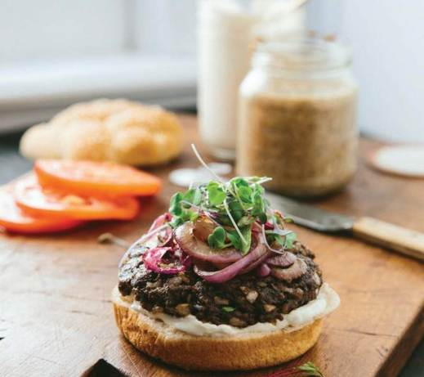
The Real Burger
(aka Now and Zen Burger)
1 lb. white or Crimini mushrooms, quartered
1 large onion, diced
4 c. cooked brown rice
¼ c. tomato paste
½ c. chopped parsley
2½ Tbsp. soy sauce or tamari
1½ Tbsp. white miso
2 tsp. dried basil
½ tsp. dried thyme
½ tsp. dried savory
1/8 tsp. ground allspice
1½ c. vital wheat gluten

- Pulse mushrooms in batches in the food processor until minced, but not mushy (or mince by hand if no processor).
- In a large bowl, add minced mushrooms, onions, rice, tomato paste, parsley, soy sauce, miso, herbs and spices and mix well (easiest by hand).
- Add wheat gluten and mix well.
- On parchment-lined cookie sheets (or lightly greased, if no parchment paper), drop balls of mixture from large ice cream scoop and flatten them with hands into burgers (or pack mixture into plastic-lined lid off of a large jar, then flip out onto sheet, re-using the plastic for the next burger).
- Bake at 350 degrees for 30 minutes. Refrigerate (about a week) or freeze (6-8 months) until use. They will firm up when cooled. Can be put on grill, warmed in an oven, or on a frying pan.

Makes about 24 burgers.
By Miyoko Schinner in “The Homemade Vegan Pantry”

Al's Greek French Fries cooked in Air Fryer
2 large russet potatoes
1 tsp. garlic powder
1 tsp. oregano
1 tsp. paprika
1 tsp. salt (or salt substitute)
2 Tbsp. chickpea flour

- Peel and cut potatoes into ¼ inch strips.
- Soak potatoes in a bowl of water for 20 minutes.
- Drain, rinse and pat dry potatoes.
- Return potatoes to bowl and season with garlic powder, oregano, paprika, salt & chickpea flour.
- Toss until potatoes are well coated.
- Preheat the air fryer to 390 degrees for 3 minutes.
- Transfer potatoes to air fryer and cook for 18 minutes.
- Stop fryer at 10 minutes and shake potatoes.
By Al Tsacle

Al's Greek French Fries cooked in Oven
Ingredients & steps are the same as above.
- Pre-heat oven to 400 degrees.
- Place parchment paper on a large baking pan.
- Spread the seasoned potatoes evenly in the pan and bake for 20 minutes.
- Turn potatoes after 10 minutes.
By Al Tsacle

BBQ Ketchup Sauce
In a saucepan, whisk the following ingredients together:

1 (6 oz.) can tomato paste (equals about 2/3 cup)
2 cans of water – rinsing out the tomato paste can (equals about 1-1/3 cups)
1 tsp. potato starch
1/3 c. coconut sugar or other healthful sugar
1 Tbsp. vegan Worcestershire sauce
1 Tbsp. apple cider vinegar
1 tsp. onion powder
1 tsp. sea salt
½ tsp. garlic powder
½ tsp. mustard powder
¼ tsp. smoked paprika

Heat until it thickens and begins to boil. Stir now and then to make sure it doesn’t scorch on the bottom. Enjoy!
By Diana Adams

Oil-Free Tofu Mayonnaise
Soak some cashews ahead of time – at least 3 or 4 hours, or overnight. This recipe takes ½ cup.

½ c. almond milk, plain, unsweetened
1 tsp. potato starch
½ c. soaked cashews
12 oz. MoriNu tofu, firm
2 Tbsp. apple cider vinegar
1 Tbsp. fresh lemon juice
½ tsp. mustard powder
1¼ tsp. sea salt
¼ tsp. black salt (optional)
1/8 tsp. raw sugar
1/8 tsp. onion powder

- First, in a pan, stir the potato starch into the almond milk. Heat and stir just until it starts to bubble.
- Next, in a blender, or in a jar if you are using an immersion blender, place the cashews and the thickened almond milk, and the rest of the ingredients.
- Blend until smooth and creamy. Done!
By Diana Adams

Vegan Worcestershire Sauce
½ c. apple cider vinegar
2 Tbsp. Bragg’s liquid aminos
2 tsp. water
1 tsp. dry sweetener (such as raw sugar)
¼ tsp. ground ginger
¼ tsp. mustard powder
¼ tsp. onion powder
¼ tsp. garlic powder
1/8 tsp. ground cinnamon
1/8 tsp. smoked paprika

Mix all in a pan and heat to a simmer. Simmer for 1 minute, stirring constantly. Cool and refrigerate.
Adapted from www.GeniusKitchen.com

Vegan Chocolate Shake
Blend the following ingredients together until smooth. Makes about 1 cup.

2/3 c. frozen banana pieces
½ Tbsp. peanut butter
½ to 1 Tbsp. cocoa powder. Use WonderCocoa for least caffeine.
¼ tsp. vanilla
½ c. almond milk, plain

By Diana Adams

Vegan Carob Shake
Blend the following ingredients together until smooth. Makes about 1 cup.

2/3 c. frozen banana pieces
½ Tbsp. peanut butter
1 tsp. carob powder
1 tsp. coffee substitute powder such as Roma or Dandy Blend
¼ tsp. vanilla
½ c. almond milk, plain

By Diana Adams

Useful Potato Diet Resources:

www.SpudFit.com https://PotatoHack.com www.DrMcDougall.com

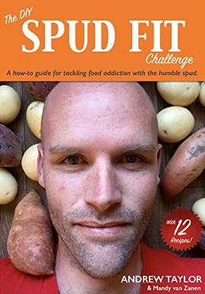
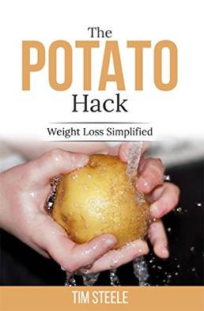
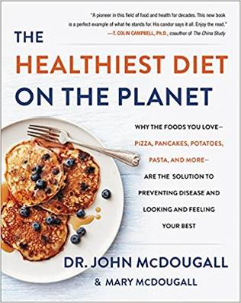
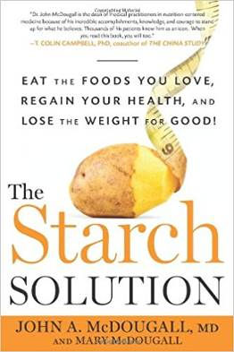

For interesting video resources, go to www.YouTube.com and search the above titles.

