Vegan Cooking Class Recipes Session 53 (January, 2018)
This & That Recipes

- Overnight Chia Oat Pudding (page 1)
- Hummus (page 1)
- Philly Cheese Steak (page2)
- Potato Chips (page 3)
- California Dip (page 3)
- Oriental Glaze (page 3)
- Basic Vegetable Stir Fry (page 4)
- Brown Rice Cooking Methods (pages 4, 5)
- Algae Oil Information (page 6)

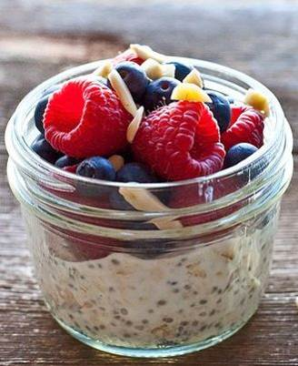

Overnight Chia Oat Pudding (makes 1 serving)
Prepare the night before.
½ c. rolled oats
1 Tbsp. chia seeds
1 date, chopped
¼ tsp. vanilla
1 c. almond milk

Combine all the ingredients and mix well. Let sit about 10 minutes until it has thickened and stir again. Cover and store it in the refrigerator overnight. In the morning it is ready to eat with a little more almond milk and some added fruit on top if desired.
By Diana Adams

Hummus
5 c. garbanzo beans (save liquid)
1/3 tsp. cumin
1/3 tsp. salt
1/3 tsp. paprika (not smoked)
¾ c. tahini
½ tsp. citrus juice (orange, lime or lemon)
3 Tbsp. oil
4 cloves garlic (minced)
Pinch of curry

Blend all of the ingredients in a food processor until smooth (approx. 15 minutes). Add liquid from the garbanzo beans as needed to thin the hummus to desired thickness.
By Karen Fryxell


PHILLY CHEESE STEAK
45 minutes to prepare
Steak:
In a bowl, add:
2 Portobello mushrooms, sliced
½ cup extra virgin cold pressed olive oil
½ cup Nama Shoyu (raw soy sauce)
2 teaspoons cumin powder
2 teaspoons coriander powder
1 tablespoon Ume plum vinegar
Set aside and let marinate.
Vegetables:
In a separate bowl, add:
1 bell pepper, seeded and sliced
1 cup broccoli, chopped
½ cup white onion, chopped
1 clove garlic, minced
1 teaspoon sea salt or to taste
¼ cup extra virgin cold pressed olive oil
Set aside and let marinate.

Cheese:
In a blender, add:
1 cup pine nuts OR cashews
½ cup sunflower seeds
2-3 tablespoons raw apple cider vinegar
¼ cup onion
1 teaspoon sea salt or to taste
½ cup distilled water
Blend until creamy.
To make the Philly Cheese Steak, start with a whole Swiss chard leaf or Romaine lettuce leaf. First spread a layer of cheese, then a layer of the steak, and finally a layer of vegetables. Roll and eat!
It can be a little messy when eating. When picking it up with your hands; the marinate may drip out. So have some napkins handy, roll up your sleeves, and enjoy.

Source: “How We All Went Raw” by Charles, Coralanne and George Nungesser

POTATO CHIPS
4 hours to soak white potatoes
20 minutes to prepare
Dehydrate until dry at 105°F
In a large bowl, add:
6 round white potatoes, thinly sliced for largest possible chips. They shrink during dehydration.
Enough distilled water to cover potatoes
Round white potatoes taste better and have less starch than other potato varieties. Soak sliced white potatoes for 4 hours and rinse twice. All other potatoes soak 24 hours in refrigerator and rinse 4 times. Rinse and drain.
In a bowl, add:
¼ cup extra virgin cold pressed olive oil
¼ cup Ume Plum Vinegar
1 teaspoon cayenne pepper
1-2 teaspoons sea salt or to taste
Mix well. Pour Marinate over sliced potatoes. Marinate for 1 hour stirring frequently. Place chips on a dehydrator tray with non-stick sheet and dehydrate for 5 hours. Turn chips over onto a mesh sheet and dehydrate until dry.
White potatoes will turn a golden color during dehydration.
TOP HAT TIP: Use a mandoline (a manually operated hand held slicing tool) or meat slicer (if you still have one around) to thinly slice potatoes. Handle with care, as the blades are very sharp.
Source: “How We All Went Raw” by Charles, Coralanne and George Nungesser

“CALIFORNIA DIP”
In a medium bowl, place:
Cheese from the Philly Cheese Steak recipe
¼ cup of dried onion flakes.
Mix well. If too thick, add a small amount of distilled water.
Goes great with chips and veggies.
Source: “How We All Went Raw” by Charles, Coralanne and George Nungesser

Oriental Glaze
2 c. pineapple juice
¼ c. cornstarch
¼ c. Bragg’s Liquid Aminos
1 tsp. garlic powder OR 2 cloves sliced fresh garlic
1 tsp. lemon juice (optional)
- Put 1½ c. water or juice in medium saucepan and bring to boil.
- Mix remaining ½ c. water or juice with the other ingredients in a cup or small bowl.
- Add cornstarch mixture to boiling liquid. Stir constantly with whisk until thickened.
- Pour over stir fry vegetables and mix for Oriental Stir Fry.
By Barbara Watson

Basic Vegetable Stir Fry
There are many, many different ways to stir-fry. But here are a few basic instructions to get you started.
Use at least a few different vegetables with different colors and textures. This is a good way to clean out your vegetable drawer in your refrigerator each week, so none of your veggies will go to waste!
Before you start cooking, wash and dry and cut and slice everything you plan to use. Slice root veggies thinly or make them into matchsticks. Quicker cooking veggies such as greens, summer squash and broccoli can be left a little bigger. Try not to have any chunks bigger than bite size.
Heat the pan until hot before adding the veggies. If using oil, it’s important to use an oil with a high temperature smoking point, such as avocado or coconut oil. Oil heated to the smoking point may be carcinogenic. So heat the oil to hot, but not smoking. It is also possible to make stir-fry without oil, or only a small amount of oil, depending on your taste and health needs. If you use a flavorful glaze on top, you will not miss the oil.
When the pan is hot enough that a drop of water sizzles when it hits, you are ready to start cooking! Put the onions in first and cook until clear. Add some garlic and ginger next, and stir for a few seconds. Then add the rest of the vegetables one at a time in order of their cooking times. Put the slower cooking veggies in first and end with the ones that need very little cooking. Keep stirring continually until all are crisp/tender. Add the glaze at the end and cook a little longer until finished. The whole thing should only take 5 -10 minutes on the stove.
Serve on rice or noodles or by itself. Can be topped with something crunchy like toasted sesame seeds or cashews for an extra special touch.

Perfect Baked Brown Rice (You can also use barley, millet or quinoa)
Ratio = 1 cup rice to 3½ cups water and 1 teaspoon of salt.
Yield = 3½ cups of perfect rice
- First dextrinize the grain to break down starch by putting it in a skillet over medium high heat, stir frequently until light brown; do this over dry heat, add no water.
- Then mix dextrinized grain with boiling water, add salt and bake covered for 90 minutes at 350 degrees.
- Bake in an oven type casserole pan with cover like Pyrex or Corning Ware.
This turns out perfect every single time!
By Susan Moskalets
How to Cook Brown Rice in the Instant Pot
No, it is not instant. The rice will still need almost an hour from start to finish. However, the advantage to using the Instant Pot is that you can leave it alone after it is started and the machine will take care of keeping the temperature just right. You won’t have to check on it.
1 c. brown rice (medium or long-grain works best)
1 c. water or vegetable broth
Salt to taste (optional)

- Put rice and water in the pot. Close the lid. Set the steam vent to the closed position. Push the “Manual” button and set the time for 20 minutes. When it is finished cooking, allow the pressure to come down naturally (don’t open the steam vent).
- If I am around when the little button falls down (pressure is gone) I like to open the pot and fluff the rice with a fork, then put the lid back on and just let it sit another 10 minutes to finish. But that isn’t necessary if you are in a hurry. It just seems to make it a little more fluffy and less sticky.
- If you use rice often, you might consider cooking a larger batch of rice and then freeze the leftovers in portion size freezer bags. That way you don’t have to cook every time you want some rice.

How to Cook Brown Rice (stovetop method)
Makes about 3 cups
1 c. medium- or long-grain brown rice
1 tsp. olive oil or sesame oil, optional
2 c. water
1 tsp. salt
- Rinse the rice: Place the rice in a large strainer or colander and rinse it thoroughly under cool water. There is no need to dry the rice before cooking; a bit of moisture on the rice is fine.
- Toast the rice (optional): Warm a teaspoon of oil over medium-high heat in the pot where you'll cook the rice. Add the rice and toast until the rice is dry and starting to look slightly toasted on the tips. It will also start to smell fragrant and nutty.
- Combine the rice and water: Slowly pour the water into the pot with the rice — if you toasted the grains, the water will steam and bubble at first. Stir in a teaspoon of salt.
- Bring to a boil, and then reduce heat to low and cover. Make sure the liquid stops boiling and has reduced to a bare simmer over low heat, then cover the pot.
- Cook for 45 minutes. Do not uncover the pot to check the rice during cooking.
- Check the rice: At the end of the cooking time, remove the cover and check to see if all the water has been absorbed; a little water on the very bottom is fine, but if there's more than a tablespoon, drain off the excess. At this point, the rice should also be chewy and tender, and no longer crunchy. If it's still crunchy, add a little more water (if needed) and continue cooking; check every 10 minutes until the rice is done.
- Cover and let stand another 10 to 15 minutes: Take the rice off heat, and place the lid back on top. Let the rice stand another 10 to 15 minutes, covered. This last step prevents the rice from becoming overly sticky and helps it lose that wet, "just-steamed" texture.
- Fluff and serve: Use a fork to fluff the rice, and then transfer it to a serving dish. Serve while warm.
- Store the leftovers: Let any leftovers cool completely, and then transfer to storage containers. Refrigerate rice for 3 to 5 days. Brown rice can also be frozen for up to 3 months.
From www.thekitchn.com
Algae Oil: Best New Superfood You Haven’t Tried Yet?
By Alexis Farah on 6/13/2016
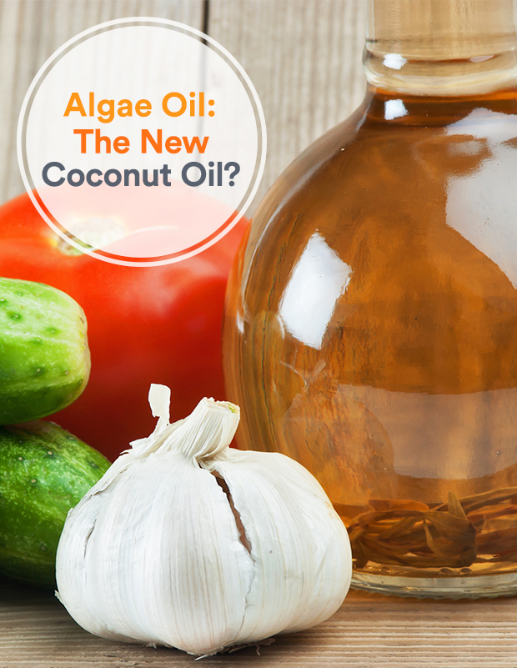
As much as we can wax poetic about coconut oil all day, the culinary scene is starting to heat up with algae oil. And based on its many health benefits, you might start adding it to your cooking repertoire, too.
“Algae oil is a nutrient dense powerhouse due to its high concentration of omega-3 fatty acids,” says Shana Pantirer, RDN, senior registered dietitian at F-Factor Nutrition. “These fatty acids are essential to our diets because our bodies cannot manufacture them,” she adds.
While you may be weary of the oil’s fishy factor (after all, the thought of algae doesn’t exactly induce food FOMO), Kelly LeVeque, a holistic nutritionist and founder of Be Well By Kelly, says it’s virtually tasteless. “If I had to compare it, I would say that it tastes similar to vegetable oil,” she says. But is it worth dipping your spoon into this new cooking craze?

Hold Up, Algae Oil?
A little back-story: The algae is first grown in a fermenter, where it feeds on plant sugars, and then is pressed to release the oil from the walls of the algae cells. “Algae oil is made specifically from micro algae,” Pantirer explains. Thrive Culinary Algae Oil, one of the main suppliers of bottled algae oil, ferments it in a sterile environment (like how you would with beer or wine) before it’s dried and pressed, for example.
But most impressively, the oil is a great source of docosahexaenoic acid (DHA), an omega-3 fatty acid that your body needs for healthy brain function, optimal heart health, among other things. In one recent study from the National Center for Biotechnology Information, researchers found that algae oil capsules have the same amount of DHA as a piece of cooked salmon. This makes algae oil a great option for vegans and people who are fish-averse or allergic to sea creatures. Plus, algae oil has twice the amount of omega-3s than chia seeds, nine times more fiber than kale, and twice more protein than spinach, LeVeque adds.
Its reputation has caused a plethora of brands to fortify their products with the oil in drinks, supplements, food and even baby formula for a nutritional boost. Chefs have also taken a liking to its high (485°F) smoke point (the temperature that oil stops simmering and starts to burn), which makes cooking easier and cuts back on fat and calories.

More Than Just a Cooking Oil
“When algae is consumed as oil, the monounsaturated omega-3 rich fatty acids help stabilize blood sugar, balance hunger hormones and help your body fight inflammation,” says LeVeque.
A study in the European Journal of Neuroscience shows that oil containing DHA may help quell symptoms of anxiety and depression, in addition to anti-depression and anti-anxiety medication.
But the list of nutritional benefits goes beyond the DHA content. “Algae oil also contains marine minerals such as iodine, which is important for thyroid health, magnesium, potassium and even calcium,” says Pantirer.

Should You Stock Up Now?
When it comes to the battle of the oils, is there really a reason to choose algae oil over its coconut shelf-mate? Yes, Pantirer says. “Algae oil has a higher abundance of monounsaturated fatty acids and less saturated fat than coconut oil.” But because algae oil is new, more research is still needed on its benefits and how it compares to other oils.
http://dailyburn.com/life/health/algae-oil-healthy-cooking-oil

