Vegan Cooking Class Recipes Session 52 (December, 2017)
More Holiday Dishes

- Cheddary Broccoli Soup (page 1)
- Vegan Holiday Loaf with Stuffing (page 2)
- Chestnut Stuffing (page3)
- Raw Cranberry/Persimmon Relish (page 3)
- Chef Ani’s Cheezy Dip (page 4)
- Banana & Almond Oatmeal Muffins (page 4)
- Pumpkin Ice Cream (page 4)
- Nürnberg Lebkuchen (page 5)
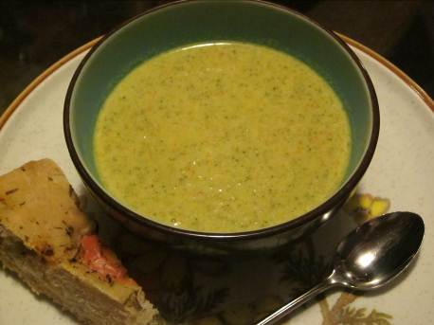
Cheddary Broccoli Soup
2 Tbsp. vegetable broth
1 small onion, diced
3 cloves garlic, minced
4 c. chopped broccoli stalks and florets
½ c. peeled, chopped carrots
½ tsp. ground turmeric
½ tsp. salt
3 c. vegetable broth

For the Cashew Cream:
1 c. raw cashews (soaked for at least 2 hours if you don’t have a high-speed blender)
2 c. vegetable broth
3 Tbsp. mellow white miso
2 Tbsp. nutritional yeast flakes
2 Tbsp. fresh lemon juice

Prepare the Soup:
- Sauté the onion in the 2 Tbsp. of vegetable broth until just softened, about 3 minutes.
- Add garlic and sauté another 30 seconds, until fragrant.
- Add the next 4 ingredients, cover and simmer for about 10 minutes.
Prepare the Cashew Cream:
- Drain and rinse the cashews. Add the cashews and next 3 ingredients (not the lemon juice) to a blender and blend until smooth.
- Add Cashew Cream to soup and cook on low, partially covered, for about 10 minutes, stirring occasionally.
- Use an immersion blender and blend until mostly smooth. (OR use a blender and blend in batches, being careful with the hot liquid).
- Add the lemon juice, taste for seasoning and serve.
Leftover soup will thicken when cool, and may have to be thinned a bit with added vegetable broth.
Inspired by Isa Chandra Moskowitz “Isa Does It”

Chef Ani’s Vegan Holiday Roast (Adams Adaptation)
You will need some of your favorite stuffing on hand before you start. (About 1 -2 cups) This recipe is to make the outer “meaty” part, which will then be wrapped and baked around the stuffing.

In a bowl mix all the dry ingredients:
1 c. gluten flour
2 Tbsp. regular flour (all purpose or whole wheat)
3 Tbsp. powdered dried mushrooms (dry ground in a small blender)
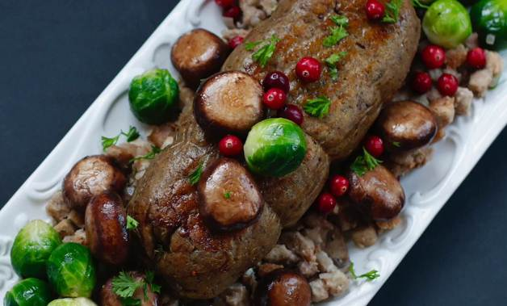
3 Tbsp. nutritional yeast flakes
2 tsp. sage
½ tsp. Herbes de Provence
1 tsp. (scant) hickory salt or regular sea salt

In a food processor, blend the following:
½ c. tofu
¼ c. toasted almond butter
¾ c. plain unsweetened almond milk
1 Tbsp. Braggs’ Liquid Aminos

- Pour and wipe out all the mixture from the food processor into the bowl of dry ingredients.
- Stir immediately with a fork until it all balls together. If the dough is too sticky and not forming a ball, add a bit more gluten flour (1 teaspoon at a time) until it works.
- You want to add as little of the gluten as you need to, so that it won’t be rubbery.
- Mash it just a few times more in your hands until the dough is thoroughly mixed – don’t overdo this.

Assembly:
- Now, on a large piece of parchment paper, flatten the dough into a rectangle about 9 x 12 inches. It should be about ½ inch thick. (These are just rough measurements. You don’t have to use a ruler!)
- Then carefully place a few tight handfuls of the stuffing down the middle longwise. We like to make it roughly the size of the core of a roll of paper towels, leaving the ends empty for about 1½ inches on each side. Try to keep the stuffing off the remainder of the dough – especially the edges. You can use more stuffing if your family really loves stuffing or less. The more stuffing, the larger the turkey. But keep in mind the dough sides need to reach up to each other in the middle.
- Next, pull up the sides of the dough, one at a time, using the parchment paper to help, until the two sides meet on top and you can pinch them together. You may need to stretch them just slightly, or remove some of the stuffing. Then pull up the ends and meld everything together gently.
- Then wrap it all up in the same piece of parchment paper and tie it with some twine. (Not necessary if the paper is well tucked under the loaf. But it’s fun!) Then wrap again in a sheet of aluminum foil to keep it from drying out as it bakes.
- Place on a pan in the oven at 350° F. for one hour. Keep wrapped until serving time. Be careful of the steam, if you open it right away. Enjoy! PS. This freezes well.

Original recipe at https://chefani.com/vegan-holiday-roast

Chestnut Stuffing
I also substitute walnuts or pecans instead of chestnuts.

3 Tbsp. vegan butter, optional
1 small onion, chopped
1 c. chopped celery
¾ Tbsp. finely chopped fresh sage (or ¾ tsp. dry)
1¼ c. vegan broth

5 c. dry bread cubes (your choice of bread)
¾ c. chopped fresh parsley (or ¼ c. dry)
1 c. cooked and chopped chestnuts (or walnuts or pecans)
Salt to taste
Grains of Paradise to taste (optional - a substitute for black pepper)

- Sauté the onion and celery in the vegan butter or a small amount of broth until clear.
- Add the sage and cook about another 3 minutes.
- Stir in about ¼ c. of the broth and let it cook another 5 minutes to reduce the broth down.
- Stir in the remainder of the broth.
- Pour the hot mix into a bowl with all the other ingredients and mix well.
- Let sit a while so that the bread can soak up all the yumminess.
Adapted from a Martha Stewart recipe

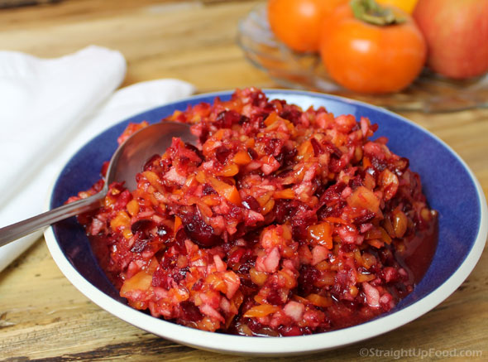

Raw Cranberry/Persimmon Relish

In a food processor, add and chop the following:
1½ c. fresh (or frozen + thawed) whole cranberries
2 ripe Fuyu persimmons, peeled and rough chopped
2 med. tangerines or 1 orange, peeled and seeded and rough chopped
1 apple, cored and rough chopped
¼ c. dates, pitted and chopped
½ tsp. Ceylon cinnamon
½ tsp. ground nutmeg (freshly grated is nice!)
Adapted from http://www.straightupfood.com/blog/2015/11/16/raw-cranberry-persimmon-relish

Chef Ani’s Roasted Garlic & Herb Cheesy Spreadable Dip
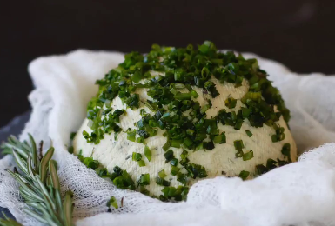
Be sure to soak the cashews 8 hours ahead of time. This is key.
1 c. cashews, soaked 8 hrs. or overnight
5 garlic cloves, peeled and roasted in foil at 350° F. for 25 minutes
3 Tbsp. fresh lemon juice
3 Tbsp. coconut milk
1 Tbsp. nutritional yeast flakes
¾ tsp. salt (I used hickory salt)
¼ c. chopped fresh herbs (such as rosemary, parsley, chives, dill, etc.)
- First, pulse the cashews in a food processor until chunky chopped.
- Then add the lemon juice and coconut milk and process until smooth.
- Add the yeast flakes, salt and garlic. Process again until smooth.
- Last, add the fresh herbs. Pulse only to mix. (Unless you want green cheese!)
- Next, scrape all the cheesy mix into a piece of cheese cloth, tie it up, and place into a small dish the shape that you want your finished ball to look like. Cover tight with plastic and chill overnight. It will firm up as it cools.
- Can be garnished for an extra special touch.
By Chef Ani at https://chefani.com/vegan-roasted-garlic-herb-cheesy-spreadable-dip

Vegan Banana & Almond Oatmeal Muffins (Gluten free)
½ c. almond butter
1½ c. mashed bananas
3 c. old fashioned oats (gluten free)
1½ c. unsweetened almond milk
½ c. maple syrup
1 tsp. vanilla extract
½ tsp. sea salt
1 c. raw sliced almonds or pumpkin seeds.
- Preheat oven to 375° and spray muffin tins.
- Mash bananas and combine all ingredients, stirring thoroughly.
- Spoon mixture into muffin tins. Bake for 20 to 25 minutes.
By Darla DeVargas

Vegan Pumpkin Ice Cream
2 cans coconut milk
½ c. almond milk
2¾ c. canned pumpkin
¼ c. pure maple syrup
¼ c. coconut sugar
2 tsp. pumpkin pie spice
¼ tsp. salt
1 ripe banana
1 small avocado-YES, avocado!
- Mix in blender place in fridge about an hour.
- Pour in ice cream maker and freeze for 25 minutes. Yummy!!
By Darla DeVargas

Nürnberg Lebkuchen

Almond meal/flour 600 grams
Whole Wheat Pastry Flour 150 grams
Diced Marzipan 200 grams
Diced candied Orange Peel 100 grams
Diced candied Lemon Peel 50 grams
Diced dried apricots 100 grams
Cinnamon 11 tsp
Ground Anise Seed 1.5 tsp
Ground Fennel Seed 1.5 tsp
Allspice 1/2 tsp
Cloves 1/2 tsp
Kardamom 1 tsp
Coriander 1 tsp
Ginger 1.5 tsp
Oblaten wafers 48 50mm wafers
Garbanzo bean liquid 1.5 cups (from 2 cans of garbanzo beans)
Sugar 1.5 cups
Ammonium Bicarbonate 10 gr
Cream of Tartar Powder 1/2 tsp
Vanilla extract 2 tsp

- Combine all dry ingredients except sugar, cream of tartar powder, and ammonium bicarbonate.
- In a mixer whip the garbanzo bean liquid, sugar, cream of tartar powder and vanilla extract until stiff peaks form to make aquafaba.
- Add the aquafaba, ammonium bicarbonate (mixed with a little water) to the dry ingredients to form a batter.
- Cover batter and let sit for 5-6 hours. With a wet knife, place batter (mound shape) onto oblation wafers. Place cookies on a baking pan lined with parchment paper and bake at 350° degrees for 20 - 22 minutes. When cool, top cookies with tempered dark chocolate.
By Lefteri Tsacle

