Vegan Cooking Class Recipes Session 51 (November, 2017)
Holiday Dishes

- Onion Cauliflower Casserole (page 1)
- Ultimate Vegan Meatloaf (page 2)
- Vegan Worcestershire Sauce (page3)
- BBQ Catsup (page 3)
- Garlic Mashed Potatoes (page 3)
- Thanksgiving Gravy (page 4)
- Delicious Vegan Chocolate Pudding (page 4)
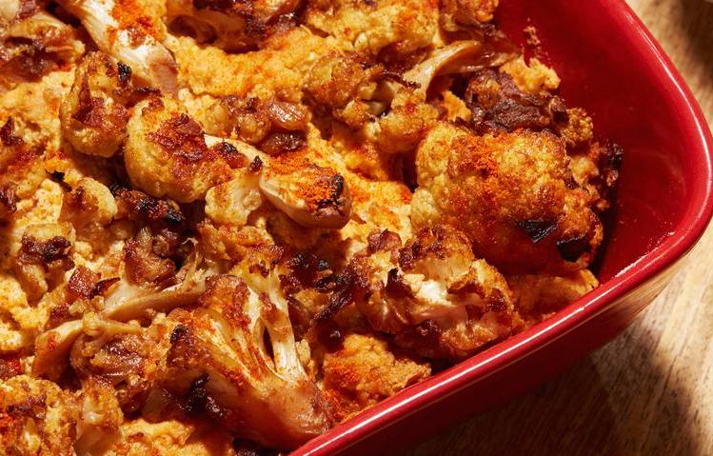

Caramelized Onion Cauliflower Casserole
2 Tbsp. water
1 large onion
4 garlic cloves, minced
4 c. cauliflower florets (1 med. head)
1 (12 oz.) package extra-firm silken tofu (aseptic package, on the shelf)
1 c. vegetable broth, purchased or homemade
½ c. tahini
1 Tbsp. fresh lemon juice
¼ c. nutritional yeast flakes
1 Tbsp. smoked paprika, plus more for sprinkling
½ tsp. salt
1 c. bread crumbs

- Heat a large skillet over low heat and add water and onion. Cover and cook, stirring occasionally, until soft and golden, about 15 minutes. Add a little water if onion starts sticking.
- Add garlic and cauliflower, cook for about 5 minutes covered, on medium heat, stirring occasionally and remove from heat. Remove half of the mixture and set aside.
- Preheat oven to 350 F. Lightly grease a 9-inch square or 11x8 inch casserole dish.
- In a food processor, combine the tofu, vegetable broth, tahini, paprika nutritional yeast, salt and lemon juice and blend till smooth. Add one half of the cauliflower mixture and pulse a couple of times till well combined. Stir in the bread crumbs.
- Transfer mixture to the prepared baking dish, spread evenly and top with reserved half of cauliflower, pressing it in lightly.
- Bake for about 30 minutes (you can broil top for a minute or two, watching it carefully to brown top a little if needed). Cool slightly, sprinkle with paprika and serve.
Source: “The Superfun Times Vegan Holiday Cookbook” by Isa Chandra Moskowitz

Ultimate Vegan Meatloaf

Sauté (with water for oil-free) the following:
10 oz. chopped mushrooms
1 c. chopped onions
½ c. chopped green bell peppers
½ c. chopped red bell peppers
4 cloves garlic, minced

It’s important to let it cook until all the extra liquid is evaporated from the vegetables.

Also add to frypan at the end and then set the pan aside to cool:
½ c. fresh chopped basil
¼ c. fresh chopped tarragon
¼ c. fresh chopped sage
¼ c. fresh chopped cilantro
¼ c. fresh chopped rosemary
1½ tsp. sea salt or to taste

Note: If you don’t have fresh herbs, you can use dry but only use 1/3 the amount.

In a food processor, pulse the following until med/fine chopped:
½ c. raw cashews
½ c. walnuts (or pecans)

Place the nuts in a large mixing bowl. Then to the food processor add:
2 cans of drained garbanzo beans (or 3 c. cooked)
Process until creamy.

Add the creamed garbanzos to the mixing bowl and add:
1 c. cooked quinoa
1 c. bread crumbs (or 2 c. Rice Chex crumbs) or more if mix is too soggy before baking
½ c. coconut milk
2 flax or chia eggs (1 egg = 1 Tbsp. flax or 1 tsp. chia + 3 Tbsp. water)
½ Tbsp. liquid smoke
3 Tbsp. vegan Worcestershire sauce (see recipe on next page for homemade)
3 Tbsp. tomato paste
3 Tbsp. nutritional yeast flakes
2 tsp. garlic powder
Sprinkle of cayenne powder (opt.)

- Also add the sautéed mix from the frypan and mix it all well. If too soupy add more crumbs.
- Line a bread pan with parchment paper and put the mix in, packing it down well as you go.
- Spread top with a thin layer (about ¼” ) of BBQ Catsup (see recipe on next page for healthier homemade).
- Bake at 350 F. for an hour. Let cool at least 2 hours. Will solidify more as it cools. Take it out of the pan after about ½ hour.
Adapted from “The Mushroom Den” on YouTube
Vegan Worcestershire Sauce
½ c. apple cider vinegar
2 Tbsp. Bragg’s amino acids
2 tsp. water
1 tsp. dry sweetener (such as raw sugar)
¼ tsp. ground ginger
¼ tsp. mustard powder
¼ tsp. onion powder
¼ tsp. garlic powder
1/8 tsp. ground cinnamon
1/8 tsp. smoked paprika

Mix all in a pan and heat to a simmer. Simmer for 1 minute, stirring constantly. Cool and refrigerate.
Adapted from www.GeniusKitchen.com

BBQ Catsup
1 (6 oz.) can tomato paste
¼ c. raw sugar
½ tsp. garlic powder
½ tsp. onion powder
1 tsp. Italian seasoning
½ tsp. pink salt
1 tsp. liquid smoke
2 Tbsp. apple cider vinegar
1 Tbsp. water or to desired consistency
Mix well and store in refrigerator.
By Diana Adams

Garlic Mashed Potatoes
4 medium Yukon Gold potatoes peeled & cut into 2-inch pieces
1 c. vegetable broth
6 cloves garlic peeled and cut in half
½ c. soy milk or other non-dairy milk
- Add potatoes, garlic & broth to the Instant Pot.
- Lock on the lid. Bring to high pressure. Cook for 4 minutes.
- Quick release the pressure & remove lid.
- Add the non-dairy milk and mash the potatoes with a potato masher.
- Season with salt.
Alternative Cooking Method if you don’t have an Instant Pot:
- Roast one bulb of Garlic in oven (about 45 minutes at 350°).
- Boil potatoes in salted water until soft.
- Drain potatoes and combine with peeled roasted garlic.
- Add non-dairy milk and mash.
- Season with salt.
Source: “Vegan Under Pressure” by Jill Nussinow

Thanksgiving Gravy
¼ c. nutritional yeast
¼ c. whole wheat pastry flour or other
1 c. non-dairy milk
1 small onion, diced
8 oz. white mushrooms, thinly sliced
2 Tbsp. soy sauce
1 tsp. rubbed sage (not powdered)
1 tsp. dried thyme
Salt, to taste

- Whisk nutritional yeast and flour together with non-dairy milk and set aside.
- Line a large frying pan with a thick layer of water and cook onion and mushrooms over high heat until the mushrooms start to soften and turn brown and most of the water has evaporated.
- Add non-dairy milk mixture, soy sauce and herbs, stirring to combine.
- Bring to a boil and continue to cook until thick.
- Add salt, if desired.
Source: “The Happy Herbivore” by Lindsay S. Nixon

Delicious, Vegan Chocolate Pudding
6 Tbsp. Wonder Cocoa Powder
½ c. coconut sugar (or more if you want sweeter pudding)
¼ tsp. salt
1/3 c. water
2 c. almond coconut milk (split 1/3 and 1-2/3)
4 Tbsp. cornstarch
1 Tbsp. vanilla extract

- Combine cocoa, sugar and salt in a medium size saucepan.
- Combine cornstarch with 1/3 c. of the almond coconut milk. Stir with a fork until smooth and set aside.
- Add water to the sugar/cocoa/salt mixture and stir making a paste. Add remaining 1-2/3 cup almond coconut milk. Bring to a boil over medium heat. Whisk in the cornstarch mixture and stir frequently until the mixture comes back to a boil. After pudding boils for 30 seconds, remove from heat and stir in vanilla.
- Pour pudding into cups or a large bowl. If you’d like to prevent a skin from forming on the pudding, place a piece of waxed paper or parchment paper directly on the pudding while it is hot.
- Cool and refrigerate for two hours or up to two days.
- Makes four ½ c. servings.
- Recipe can be doubled
Additions:
Stir in 2 oz. vegan chocolate chips
1 tsp. other extracts – orange, mint, etc.

Adapted from: “More Great, Good Dairy-free Desserts - Naturally” by Fran Costigan

